Chapter 4

The Time Value of Money
4-1. You have just taken out a five-year loan from a bank to buy an engagement ring. The ring costs $5000. You plan to put down $1000 and borrow $4000. You will need to make annual payments of $1000 at the end of each year. Show the timeline of the loan from your perspective. How would the timeline differ if you created it from the bank’s perspective?
0 |  | 1 |  | 2 |  | 3 |  | 4 |  | 5
4000 |  | –1000 |  | –1000 |  | –1000 |  | –1000 |  | –1000
From the bank’s perspective, the timeline is the same except all the signs are reversed.
4-2. You currently have a four-year-old mortgage outstanding on your house. You make monthly payments of $1500. You have just made a payment. The mortgage has 26 years to go (i.e., it had an original term of 30 years). Show the timeline from your perspective. How would the timeline differ if you created it from the bank’s perspective?
0 |  | 1 |  | 2 |  | 3 |  | 4 |  |  |  |  | 312
 |  | –1500 |  | –1500 |  | –1500 |  | –1500 |  |  |  |  | –1500
From the bank’s perspective, the timeline would be identical except with opposite signs.
4-3. Calculate the future value of $2000 in:
a. Five years at an interest rate of 5% per year.
b. Ten years at an interest rate of 5% per year.
c. Five years at an interest rate of 10% per year.
d. Why is the amount of interest earned in part (a) less than half the amount of interest earned in part (b)?
a. Timeline:
0 |  | 1 |  | 2 |  |  |  |  | 5
2000 |  | FV = ?
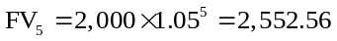
b. Timeline:
0 |  | 1 |  | 2 |  |  |  |  | 10
2000 |  | FV = ?
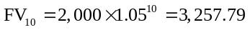
c. Timeline:
0 |  | 1 |  | 2 |  |  |  |  | 5
2000 |  | FV = ?
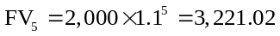
d. Because in the last 5 years you get interest on the interest earned in the first 5 years as well as interest on the original $2,000.
4-4. What is the present value of $10,000 received:
a. Twelve years from today when the interest rate is 4% per year?
b. Twenty years from today when the interest rate is 8% per year?
c. Six years from today when the interest rate is 2% per year?
a. Timeline:
0 |  | 1 |  | 2 |  | 3 |  |  |  |  | 12
PV = ? |  |  |  |  |  |  |  |  |  |  | 10,000
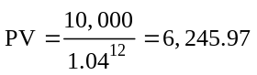
b. Timeline:
0 |  | 1 |  | 2 |  | 3 |  |  |  |  | 20
PV = ? |  |  |  |  |  |  |  |  |  |  | 10,000
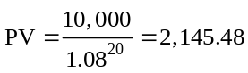
c. Timeline:
0 |  | 1 |  | 2 |  | 3 |  | 4 |  | 5 |  | 6
PV = ? |  |  |  |  |  |  |  |  |  |  |  | 10,000
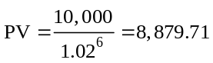
4-5. Your brother has offered to give you either $5000 today or $10,000 in 10 years. If the interest rate is 7% per year, which option is preferable?
Timeline:
0 |  | 1 |  | 2 |  | 3 |  | 4 |  |  |  |  | 10
PV = ? |  |  |  |  |  |  |  |  |  |  |  |  | 10,000
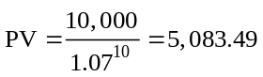
So the 10,000 in 10 years is preferable because it is worth more.
4-6. Consider the following alternatives:
i. $100 received in one year
ii. $200 received in five years
iii. $300 received in ten years
a. Rank the alternatives from most valuable to least valuable if the interest rate is 10% per year.
b. What is your ranking if the interest rate is only 5% per year?
c. What is your ranking if the interest rate is 20% per year?
a. Option ii > Option iii > Option i
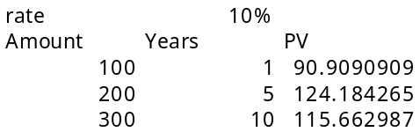
b. Option iii > Option ii > Option i
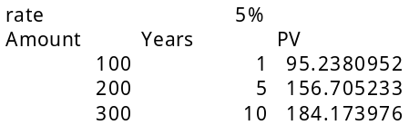
c. Option i > Option ii > Option iii
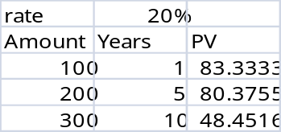
4-7. Suppose you invest $1000 in an account paying 8% interest per year.
a. What is the balance in the account after 3 years? How much of this balance corresponds to “interest on interest”?
b. What is the balance in the account after 25 years? How much of this balance corresponds to interest on interest?
a. The balance after 3 years is $1259.71; interest on interest is $19.71.
b. The balance after 25 years is $6848.48; interest on interest is $3848.48.
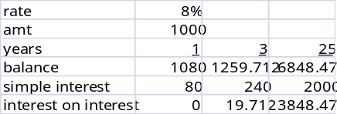
4-8. Your daughter is currently eight years old. You anticipate that she will be going to college in 10 years. You would like to have $100,000 in a savings account to fund her education at that time. If the account promises to pay a fixed interest rate of 3% per year, how much money do you need to put into the account today to ensure that you will have $100,000 in 10 years?
Timeline:
0 |  | 1 |  | 2 |  | 3 |  |  |  |  | 10
PV = ? |  |  |  |  |  |  |  |  |  |  | 100,000
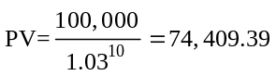
4-9. You are thinking of retiring. Your retirement plan will pay you either $250,000 immediately on retirement or $350,000 five years after the date of your retirement. Which alternative should you choose if the interest rate is:
a. 0% per year?
b. 8% per year?
c. 20% per year?
Timeline: Same for all parts
0 |  | 1 |  | 2 |  | 3 |  | 4 |  | 5
PV = ? |  |  |  |  |  |  |  |  |  | 350,000

a. 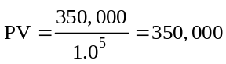
So you should take the 350,000.
b. 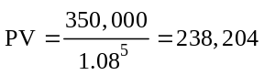
You should take the 250,000.
c. 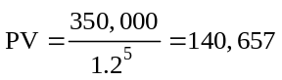
You should take the 250,000.
4-10. Your grandfather put some money in an account for you on the day you were born. You are now 18 years old and are allowed to withdraw the money for the first time. The account currently has $3996 in it and pays an 8% interest rate.
a. How much money would be in the account if you left the money there until your 25th birthday?
b. What if you left the money until your 65th birthday?
c. How much money did your grandfather originally put in the account?
a. Timeline:
18 |  | 19 |  | 20 |  | 21 |  |  |  |  | 25
0 |  | 1 |  | 2 |  | 3 |  |  |  |  | 7
3,996 |  | FV = ?
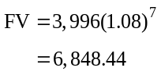
b. Timeline:
18 |  | 19 |  | 20 |  | 21 |  |  |  |  | 65
0 |  | 1 |  | 2 |  | 3 |  |  |  |  | 47
3,996 |  | FV = ?
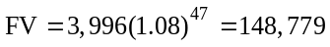
c. Timeline:
0 |  | 1 |  | 2 |  | 3 |  | 4 |  |  |  |  | 18
PV=? |  |  |  |  |  |  |  |  |  |  |  |  | 3,996
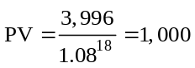
4-11. Suppose you receive $100 at the end of each year for the next three years.
a. If the interest rate is 8%, what is the present value of these cash flows?
b. What is the future value in three years of the present value you computed in (a)?
c. Suppose you deposit the cash flows in a bank account that pays 8% interest per year. What is the balance in the account at the end of each of the next three years (after your deposit is made)? How does the final bank balance compare with your answer in (b)?
a. $257.71
b. $324.64
c. $324.64
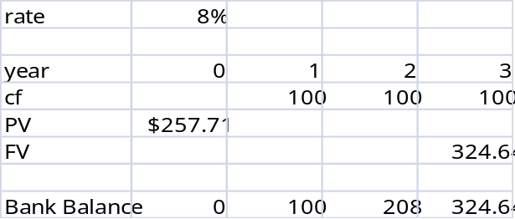

4-12. You have just received a windfall from an investment you made in a friend’s business. He will be paying you $10,000 at the end of this year, $20,000 at the end of the following year, and $30,000 at the end of the year after that (three years from today). The interest rate is 3.5% per year.
a. What is the present value of your windfall?
b. What is the future value of your windfall in three years (on the date of the last payment)?
a. Timeline:
0 |  | 1 |  | 2 |  | 3
 |  | 10,000 |  | 20,000 |  | 30,000
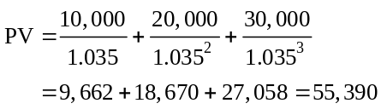
b. Timeline:
0 |  | 1 |  | 2 |  | 3
 |  | 10,000 |  | 20,000 |  | 30,000
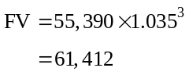
4-13. You have a loan outstanding. It requires making three annual payments at the end of the next three years of $1000 each. Your bank has offered to allow you to skip making the next two payments in lieu of making one large payment at the end of the loan’s term in three years. If the interest rate on the loan is 5%, what final payment will the bank require you to make so that it is indifferent between the two forms of payment?
Timeline:
0 |  | 1 |  | 2 |  | 3
 |  | 1,000 |  | 1,000 |  | 1,000
First, calculate the present value of the cash flows:
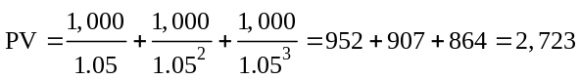
Once you know the present value of the cash flows, compute the future value (of this present value) at date 3.
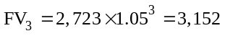
4-14. You have been offered a unique investment opportunity. If you invest $10,000 today, you will receive $500 one year from now, $1500 two years from now, and $10,000 ten years from now.
a. What is the NPV of the opportunity if the interest rate is 6% per year? Should you take the opportunity?
b. What is the NPV of the opportunity if the interest rate is 2% per year? Should you take it now?
Timeline:
0 |  | 1 |  | 2 |  | 3 |  |  |  |  | 10
-10,000 |  | 500 |  | 1,500 |  |  |  |  |  |  | 10,000
a. 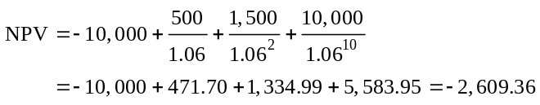
Since the NPV < 0, don’t take it.
b. 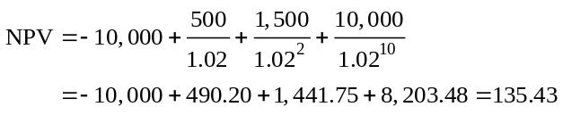
Since the NPV > 0, take it.
4-15. Marian Plunket owns her own business and is considering an investment. If she undertakes the investment, it will pay $4000 at the end of each of the next three years. The opportunity requires an initial investment of $1000 plus an additional investment at the end of the second year of $5000. What is the NPV of this opportunity if the interest rate is 2% per year? Should Marian take it?
Timeline:
0 |  | 1 |  | 2 |  | 3
–1,000 |  | 4,000 |  | –1,000 |  | 4,000
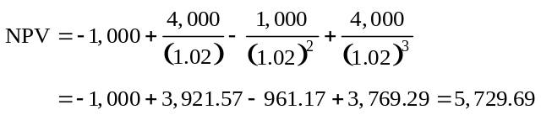
Yes, make the investment.
4-16. Your buddy in mechanical engineering has invented a money machine. The main drawback of the machine is that it is slow. It takes one year to manufacture $100. However, once built, the machine will last forever and will require no maintenance. The machine can be built immediately, but it will cost $1000 to build. Your buddy wants to know if he should invest the money to construct it. If the interest rate is 9.5% per year, what should your buddy do?
Timeline:

0 |  | 1 |  | 2 |  | 3
–1,000 |  | 100 |  | 100 |  | 100

To decide whether to build the machine you need to calculate the NPV. The cash flows the machine generates are a perpetuity, so by the PV of a perpetuity formula:
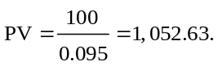
So the . He should build it.
4-17. How would your answer to Problem 16 change if the machine takes one year to build?
Timeline:
0 |  | 1 |  | 2 |  | 3
–1,000 |  |  |  | 100 |  | 100
To decide whether to build the machine, you need to calculate the NPV: The cash flows the machine generates are a perpetuity with first payment at date 2. Computing the PV at date 1 gives:
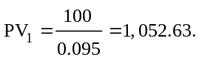

So the value today is
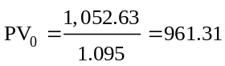. So the
He should not build the machine.
4-18. The British government has a consol bond outstanding paying £100 per year forever. Assume the current interest rate is 4% per year.
a. What is the value of the bond immediately after a payment is made?
b. What is the value of the bond immediately before a payment is made?
Timeline:
0 |  | 1 |  | 2 |  | 3
 |  | 100 |  | 100 |  | 100
a. The value of the bond is equal to the present value of the cash flows. By the perpetuity formula:
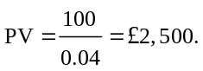
b. The value of the bond is equal to the present value of the cash flows. The cash flows are the perpetuity plus the payment that will be received immediately.

PV = 100/0.04 + 100 = £2,600
4-19. What is the present value of $1000 paid at the end of each of the next 100 years if the interest rate is 7% per year?
Timeline:
0 |  | 1 |  | 2 |  | 3 |  |  |  |  | 100
 |  | 1,000 |  | 1,000 |  | 1,000 |  |  |  |  | 1,000
The cash flows are a 100-year annuity, so by the annuity formula:
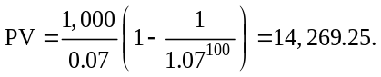
4-20. You are head of the Schwartz Family Endowment for the Arts. You have decided to fund an arts school in the San Francisco Bay area in perpetuity. Every five years, you will give the school $1 million. The first payment will occur five years from today. If the interest rate is 8% per year, what is the present value of your gift?
Timeline:
0 |  | 5 |  | 10 |  | 20
0 |  | 1 |  | 2 |  | 3
 |  | 1,000,000 |  | 1,000,000 |  | 1,000,000

First we need the five-year interest rate. If the annual interest rate is 8% per year and you invest $1 million for five years you will have, by the 2nd rule of time travel,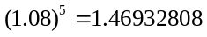. So the five-year interest rate is 46.93%. The cash flows are a perpetuity, so:
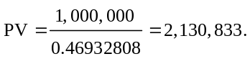
4-21. When you purchased your house, you took out a 30-year annual-payment mortgage with an interest rate of 6% per year. The annual payment on the mortgage is $12,000. You have just made a payment and have now decided to pay the mortgage off by repaying the outstanding balance. What is the payoff amount if:
a. You have lived in the house for 12 years (so there are 18 years left on the mortgage)?
b. You have lived in the house for 20 years (so there are 10 years left on the mortgage)?
c. You have lived in the house for 12 years (so there are 18 years left on the mortgage) and you decide to pay off the mortgage immediately before the twelfth payment is due?
a. Timeline:
12 |  | 13 |  | 14 |  | 15 |  |  |  |  | 30
0 |  | 1 |  | 2 |  | 3 |  |  |  |  | 18
 |  | 12,000 |  | 12,000 |  | 12,000 |  |  |  |  | 12,000
To pay off the mortgage you must repay the remaining balance. The remaining balance is equal to the present value of the remaining payments. The remaining payments are an 18-year annuity, so:
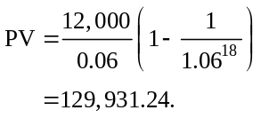
b. Timeline:
21 |  | 22 |  | 23 |  | 24 |  |  |  |  | 30
0 |  | 1 |  | 2 |  | 3 |  |  |  |  | 10
 |  | 12,000 |  | 12,000 |  | 12,000 |  |  |  |  | 12,000
To pay off the mortgage you must repay the remaining balance. The remaining balance is equal to the present value of the remaining payments. The remaining payments are a 10-year annuity, so:
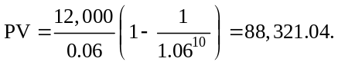
c. Timeline:
12 |  | 13 |  | 14 |  | 15 |  |  |  |  | 30
0 |  | 1 |  | 2 |  | 3 |  |  |  |  | 18
12,000 |  | 12,000 |  | 12,000 |  | 12,000 |  |  |  |  | 12,000
If you decide to pay off the mortgage immediately before the twelfth payment, you will have to pay exactly what you paid in part (a) as well as the twelfth payment itself:
4-22. You are 25 years old and decide to start saving for your retirement. You plan to save $5000 at the end of each year (so the first deposit will be one year from now), and will make the last deposit when you retire at age 65. Suppose you earn 8% per year on your retirement savings.
a. How much will you have saved for retirement?
b. How much will you have saved if you wait until age 35 to start saving (again, with your first deposit at the end of the year)?
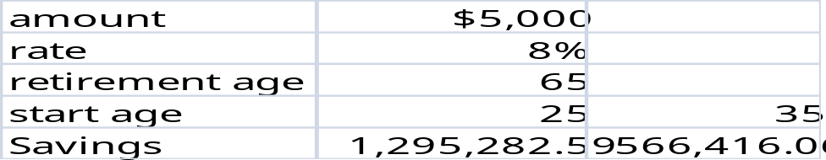
4-23. Your grandmother has been putting $1000 into a savings account on every birthday since your first (that is, when you turned 1). The account pays an interest rate of 3%. How much money will be in the account on your 18th birthday immediately after your grandmother makes the deposit on that birthday?
Timeline:
0 |  | 1 |  | 2 |  | 3 |  |  |  |  | 18
 |  | 1,000 |  | 1,000 |  | 1,000 |  |  |  |  | 1,000
We first calculate the present value of the deposits at date 0. The deposits are an 18-year annuity:
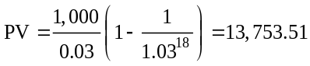
Now, we calculate the future value of this amount:
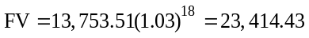
4-24. A rich relative has bequeathed you a growing perpetuity. The first payment will occur in a year and will be $1000. Each year after that, you will receive a payment on the anniversary of the last payment that is 8% larger than the last payment. This pattern of payments will go on forever. If the interest rate is 12% per year,
a. What is today’s value of the bequest?
b. What is the value of the bequest immediately after the first payment is made?
a. Timeline:
0 |  | 1 |  | 2 |  | 3
 |  | 1,000 |  | 1,000(1.08) |  | 1,000(1.08)²
Using the formula for the PV of a growing perpetuity gives:
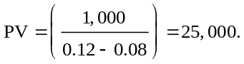
b. Timeline:
1 |  | 2 |  | 3 |  | 4
0 |  | 1 |  | 2 |  | 3
 |  | 1,000 |  | 1,000(1.08)² |  | 1,000(1.08)³
Using the formula for the PV of a growing perpetuity gives:
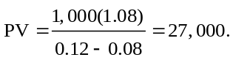
4-25. You are thinking of building a new machine that will save you $1000 in the first year. The machine will then begin to wear out so that the savings decline at a rate of 2% per year forever. What is the present value of the savings if the interest rate is 5% per year?
Timeline:
0 |  | 1 |  | 2 |  | 3
 |  | 1,000 |  | 1,000(1 – 0.02) |  | 1,000(1 – 0.02)²

We must value a growing perpetuity with a negative growth rate of –0.02:
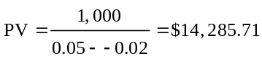
4-26. You work for a pharmaceutical company that has developed a new drug. The patent on the drug will last 17 years. You expect that the drug’s profits will be $2 million in its first year and that this amount will grow at a rate of 5% per year for the next 17 years. Once the patent expires, other pharmaceutical companies will be able to produce the same drug and competition will likely drive profits to zero. What is the present value of the new drug if the interest rate is 10% per year?
Timeline:
0 |  | 1 |  | 2 |  | 3 |  |  |  |  | 17
 |  | 2 |  | 2(1.05) |  | 2(1.05)² |  |  |  |  | 2(1.05)¹⁶

This is a 17-year growing annuity. By the growing annuity formula we have
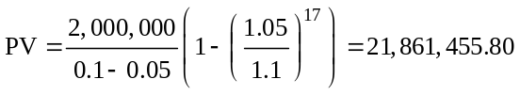
4-27. Your oldest daughter is about to start kindergarten at a private school. Tuition is $10,000 per year, payable at the beginning of the school year. You expect to keep your daughter in private school through high school. You expect tuition to increase at a rate of 5% per year over the 13 years of her schooling. What is the present value of the tuition payments if the interest rate is 5% per year? How much would you need to have in the bank now to fund all 13 years of tuition?

Timeline:
0 |  | 1 |  | 2 |  | 3 |  |  |  |  | 12 |  | 13
10,000 |  | 10,000(1.05) |  | 10,000(1.05)² |  | 10,000(1.05)³ |  |  |  |  | 10,000(1.05)¹² |  | 0
This problem consist of two parts: today’s tuition payment of $10,000 and a 12-year growing annuity with first payment of 10,000(1.05). However we cannot use the growing annuity formula because in this case r = g. We can just calculate the present values of the payments and add them up:
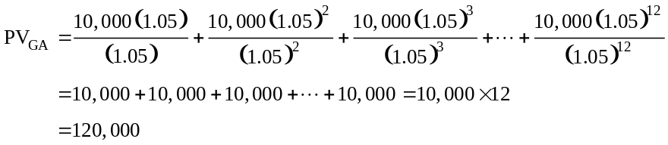
Adding the initial tuition payment gives:
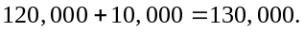
4-28. A rich aunt has promised you $5000 one year from today. In addition, each year after that, she has promised you a payment (on the anniversary of the last payment) that is 5% larger than the last payment. She will continue to show this generosity for 20 years, giving a total of 20 payments. If the interest rate is 5%, what is her promise worth today?

Timeline:
0 |  | 1 |  | 2 |  | 3 |  |  |  |  | 20
 |  | 5,000 |  | 5000(1.05) |  | 5000(1.05)² |  |  |  |  | 5000(1.05)¹⁹
This value is equal to the PV of a 20-year annuity with a first payment of $5,000. However we cannot use the growing annuity formula because in this case r = g. So instead we can just find the present values of the payments and add them up:
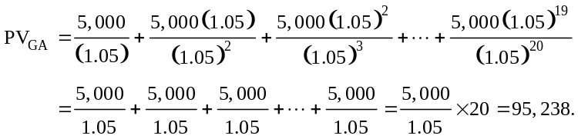
4-29. You are running a hot Internet company. Analysts predict that its earnings will grow at 30% per year for the next five years. After that, as competition increases, earnings growth is expected to slow to 2% per year and continue at that level forever. Your company has just announced earnings of $1,000,000. What is the present value of all future earnings if the interest rate is 8%? (Assume all cash flows occur at the end of the year.)

Timeline:
0 |  | 1 |  | 2 |  | 3 |  | 4 |  | 5 |  | 6 |  | 7
 |  | 1(1.3) |  | (1.3)² |  | (1.3)³ |  | (1.3)⁴ |  | (1.3)⁵ |  | (1.3)⁵(1.02) |  | (1.3)⁵(1.02)²

This problem consists of two parts:
(1) A growing annuity for 5 years;
(2) A growing perpetuity after 5 years.
First we find the PV of (1):
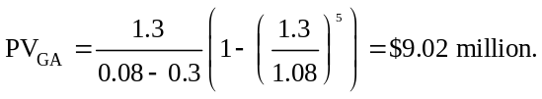

Now we calculate the PV of (2). The value at date 5 of the growing perpetuity is
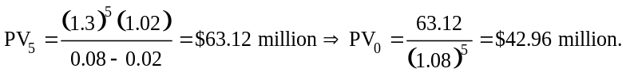
Adding the present value of (1) and (2) together gives the PV value of future earnings:
4-30. Your brother has offered to give you $100, starting next year, and after that growing at 3% for the next 20 years. You would like to calculate the value of this offer by calculating how much money you would need to deposit in the local bank so that the account will generate the same cash flows as he is offering you. Your local bank will guarantee a 6% annual interest rate so long as you have money in the account.
a. How much money will you need to deposit into the account today?
b. Using an Excel spreadsheet, show explicitly that you can deposit this amount of money into the account, and every year withdraw what your brother has promised, leaving the account with nothing after the last withdrawal.
a. The amount to be deposited in the account is $1456.15.
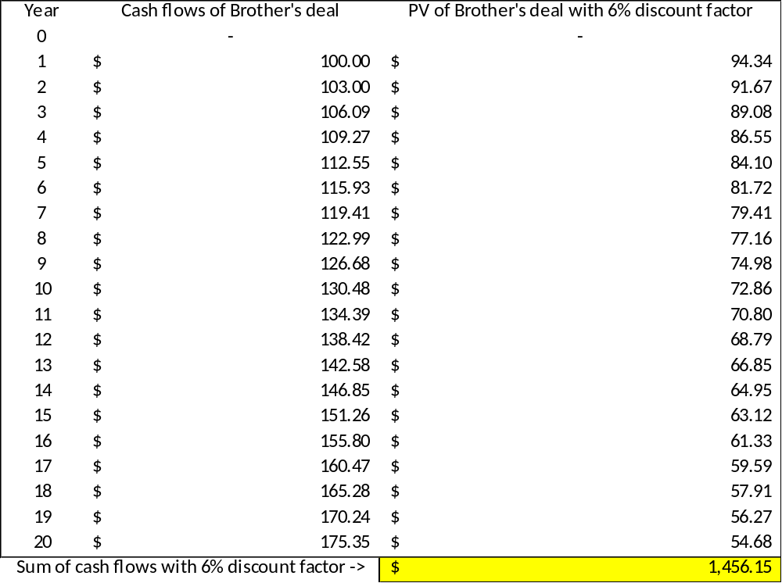
b.
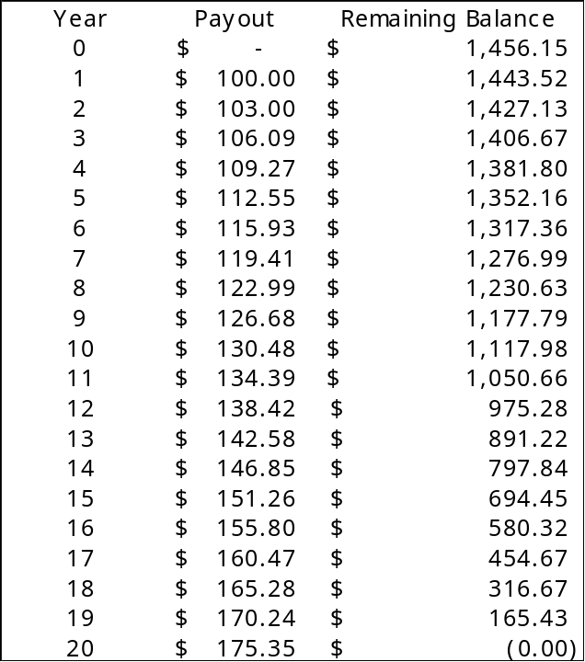
4-31. Suppose you currently have $5000 in your savings account, and your bank pays interest at a rate of 0.5% per month. If you make no further deposits or withdrawals, how much will you have in the account in 5 years?

We calculate the future value as FV = C × (1+r)^{n}. The initial amount C = $5000 and the interest rate r = 0.5% per month. Because we have a monthly interest rate, we also need to express the number of periods, n, in months, so n = 5 × 12 = 60. Thus,

FV = $5000 × 1.005⁶⁰ = $6744.25

We will have $6744.25 in the account in 5 years time.
4-32. Your firm spends $5000 every month on printing and mailing costs, sending statements to customers. If the interest rate is 0.5% per month, what is the present value of eliminating this cost by sending the statements electronically?
The $5000 cost is a monthly perpetuity. Using the perpetuity formula with monthly cash flows and the monthly interest rate, this cost has a present value of $5000/.005 = $1 million.
4-33. You have just entered an MBA program and have decided to pay for your living expenses using a credit card that has no minimum monthly payment. You intend to charge $1000 per month on the card for the next 21 months. The card carries a monthly interest rate of 1%. How much money will you owe on the card 22 months from now, when you receive your first statement post-graduation?
We want to compute the future value of our account balance. Let’s begin with the timeline over the next 12 months:

 |  | 1 |  | 2 |  |  |  |  | 21 |  | 22
 |  | 1000 |  | 1000 |  |  |  |  | 1000 |  | ?

Our charges correspond to a 21-month annuity. Therefore, using the FV of an annuity formula, the future value at the end of 21 months is:
FV(Annuity) = $1000 × 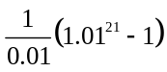 = $23,239.19
Or using the annuity calculator:

Of course, we are not quite done. When we receive our statement in the 22nd month, there will be one more month’s worth of interest charged. Therefore, we will have a final balance of $23,239.19 × 1.01 = $23.471.58.

Note that the future value formula for an annuity computes the future value as of the date of the last payment. In this question we need to compute the future value one month after the final payment, which requires an additional calculation. (We could have alternatively computed the PV of the annuity, and then computed its future value 22 months in the future.)
4-34. Your credit card charges an interest rate of 2% per month. You have a current balance of $1000, and want to pay it off. Suppose you can afford to pay off $100 per month. What will your balance be at the end of one year?
We want to compute the future value of our account balance. Let’s begin with the timeline over the next 12 months:
 |  | 1 |  | 2 |  |  |  |  | 12
1000 |  | –100 |  | –100 |  |  |  |  | –100
From the timeline we can see that we need to combine the FV of our current balance with the FV of our annuity payments of $100 per month:

FV(current balance) = $1000 × (1.02)¹² = $1268.24
FV(payments) = -$100 × 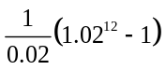 = –$1341.21
Future account balance = –$72.97

Thus, we will have overpaid by $72.97 after one year.
We can also solve this directly using the annuity spreadsheet:

 | NPER | RATE | PV | PMT | FV | Excel Formula
Given | 12 | 2.00% | –1000 | 100
Solve for FV |  |  |  |  | –73 | =FV(0.02,12,100,-1000)
4-35. You have decided to buy a perpetuity. The bond makes one payment at the end of every year forever and has an interest rate of 5%. If you initially put $1000 into the bond, what is the payment every year?
Timeline:
0 |  | 1 |  | 2 |  | 3
–1,000 |  | C |  | C |  | C
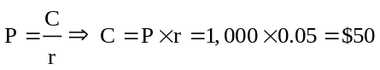
4-36. You are thinking of purchasing a house. The house costs $350,000. You have $50,000 in cash that you can use as a down payment on the house, but you need to borrow the rest of the purchase price. The bank is offering a 30-year mortgage that requires annual payments and has an interest rate of 7% per year. What will your annual payment be if you sign up for this mortgage?
Timeline: (From the perspective of the bank)
0 |  | 1 |  | 2 |  | 3 |  |  |  |  | 30
–300,000 |  | C |  | C |  | C |  |  |  |  | C
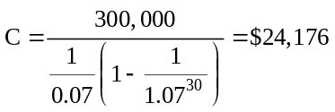
4-37. You would like to buy the house and take the mortgage described in Problem 36. You can afford to pay only $23,500 per year. The bank agrees to allow you to pay this amount each year, yet still borrow $300,000. At the end of the mortgage (in 30 years), you must make a balloon payment; that is, you must repay the remaining balance on the mortgage. How much will this balloon payment be?
Timeline: (where X is the balloon payment.)
0 |  | 1 |  | 2 |  | 3 |  |  |  |  | 30
–300,000 |  | 23,500 |  | 23,500 |  | 23,500 |  |  |  |  | 23,500 + X
The present value of the loan payments must be equal to the amount borrowed:
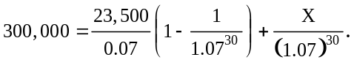
Solving for X:
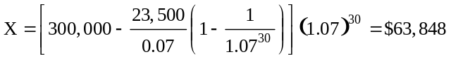
4-38. You have just made an offer on a new home and are seeking a mortgage. You need to borrow
$600,000.
a. The bank offers a 30-year mortgage with fixed monthly payments and an interest rate of 0.5% per month. What is the amount of your monthly payment if you take this loan?
b. Alternatively, you can get a 15-year mortgage with fixed monthly payments and an interest rate of 0.4% per month. How much would your monthly payments be if you take this loan instead?

a. Note that a 30-year loan has 30 × 12 = 360 monthly payments. Here is the timeline:
 |  | 1 |  | 2 |  |  |  |  | 360
P = 600,000 |  | –C |  | –C |  |  |  |  | –C
We can solve for the loan payment using the formula:
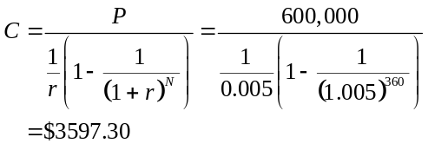
Or, using the annuity calculator:

b. Note that a 15-year loan has 15 × 12 = 180 monthly payments. Here is the timeline:
 |  | 1 |  | 2 |  |  |  |  | 180
P = 600,000 |  | –C |  | –C |  |  |  |  | –C
We can solve for the loan payment using the formula
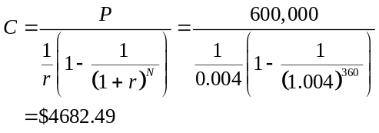
Or, using the annuity calculator:
4-39. Suppose you take the 30-year mortgage described in Problem 38 part (a). How much will you still owe on the mortgage after 15 years?

Note that a 30-year loan has 30 × 12 = 360 monthly payments. Here is the timeline:
 |  | 1 |  | 2 |  |  |  |  | 360
P = 600,000 |  | –C |  | –C |  |  |  |  | –C

We can solve for the loan payment using the formula:
Or, using the annuity calculator:
Now, after 15 years only 15 × 12 = 180 monthly payments have been made, and 180 remain. Here is the timeline of the remaining payments:
 |  | 1 |  | 2 |  |  |  |  | 180
 |  | –3597.30 |  | –3597.30 |  |  |  |  | –3597.30

We can solve for the remaining loan amount by calculating the present value of these payments at the loan rate:
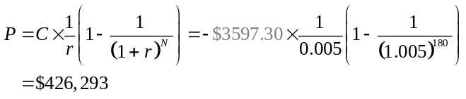
Or, using the annuity calculator:

Note that over 70% of the original balance remains!
4-40. You are thinking about buying a piece of art that costs $50,000. The art dealer is proposing the following deal: He will lend you the money, and you will repay the loan by making the same payment every two years for the next 20 years (i.e., a total of 10 payments). If the interest rate is 4% per year, how much will you have to pay every two years?
Timeline:
0 |  | 2 |  | 4 |  | 6 |  |  |  |  | 20
0 |  | 1 |  | 2 |  | 3 |  |  |  |  | 10
–50,000 |  | C |  | C |  | C |  |  |  |  | C
This cash flow stream is an annuity. First, calculate the 2-year interest rate: the 1-year rate is 4%, and $1 today will be worth (1.04)² = 1.0816 in 2 years, so the 2-year interest rate is 8.16%. Using the equation for an annuity payment:
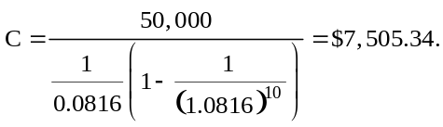
4-41. You are saving for retirement. To live comfortably, you decide you will need to save $2 million by the time you are 65. Today is your 30th birthday, and you decide, starting today and continuing on every birthday up to and including your 65th birthday, that you will put the same amount into a savings account. If the interest rate is 5%, how much must you set aside each year to make sure that you will have $2 million in the account on your 65th birthday?
Timeline:
30 |  | 31 |  | 32 |  | 33 |  |  |  |  | 65
0 |  | 1 |  | 2 |  | 3 |  |  |  |  | 35
C |  | C |  | C |  | C |  |  |  |  | C

FV = $2 million
The PV of the cash flows must equal the PV of $2 million in 35 years. The cash flows consist of a 35-year annuity, plus the contribution today, so the PV is:
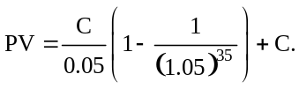

The PV of $2 million in 35 years is:
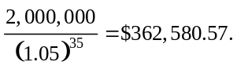
Setting these equal gives:
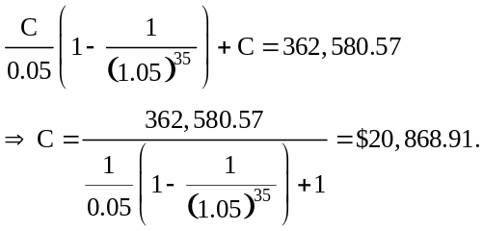
4-42. You realize that the plan in Problem 41 has a flaw. Because your income will increase over your lifetime, it would be more realistic to save less now and more later. Instead of putting the same amount aside each year, you decide to let the amount that you set aside grow by 3% per year. Under this plan, how much will you put into the account today? (Recall that you are planning to make the first contribution to the account today.)
Timeline:
30 |  | 31 |  | 32 |  | 33 |  |  |  |  | 65
0 |  | 1 |  | 2 |  | 3 |  |  |  |  | 35
C |  | C(1.03) |  | C(1.03)² |  | C(1.03)³ |  |  |  |  | C(1.03)³⁵
FV = 2 million
The PV of the cash flows must equal the PV of $2 million in 35 years. The cash flow consists of a 35-year growing annuity, plus the contribution today. So the PV is:
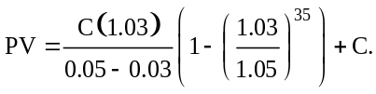
The PV of $2 million in 35 years is:
Setting these equal gives:
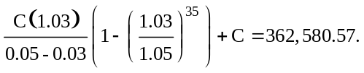
Solving for C,
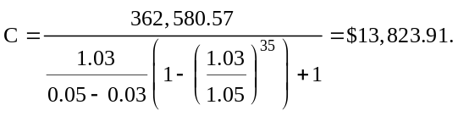
4-43. You are 35 years old, and decide to save $5000 each year (with the first deposit one year from now), in an account paying 8% interest per year. You will make your last deposit 30 years from now when you retire at age 65. During retirement, you plan to withdraw funds from the account at the end of each year (so your first withdrawal is at age 66). What constant amount will you be able to withdraw each year if you want the funds to last until you are 90?
$53,061
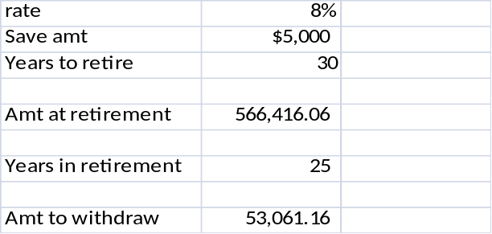
4-44. You have just turned 30 years old, have just received your MBA, and have accepted your first job. Now you must decide how much money to put into your retirement plan. The plan works as follows: Every dollar in the plan earns 7% per year. You cannot make withdrawals until you retire on your sixty-fifth birthday. After that point, you can make withdrawals as you see fit. You decide that you will plan to live to 100 and work until you turn 65. You estimate that to live comfortably in retirement, you will need $100,000 per year starting at the end of the first year of retirement and ending on your 100th birthday. You will contribute the same amount to the plan at the end of every year that you work. How much do you need to contribute each year to fund your retirement?
Timeline:
30 |  | 31 |  | 32 |  |  |  |  | 65 |  | 66 |  | 67 |  |  |  |  | 100
0 |  | 1 |  | 2 |  |  |  |  | 35 |  | 36 |  | 37 |  |  |  |  | 70
 |  | –C |  | –C |  |  |  |  | –C |  | 100 |  | 100 |  |  |  |  | 100
The present value of the costs must equal the PV of the benefits. So begin by dividing the problem into two parts, the costs and the benefits.
Costs: The costs are the contributions, a 35-year annuity with the first payment in one year:
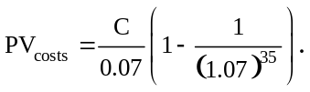
Benefits: The benefits are the payouts after retirement, a 35-year annuity paying $100,000 per year with the first payment 36 years from today. The value of this annuity in year 35 is:
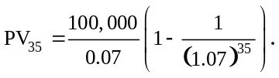
The value today is just the discounted value in 35 years:
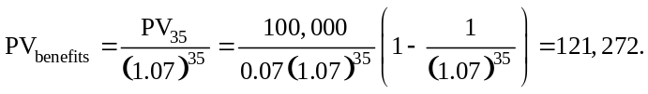
Since the PV of the costs must equal the PV of the benefits (or equivalently the NPV of the cash flow must be zero):
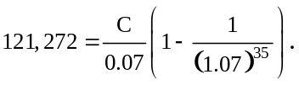
Solving for C gives:
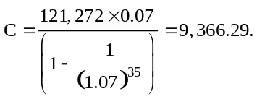
4-45. Problem 44 is not very realistic because most retirement plans do not allow you to specify a fixed amount to contribute every year. Instead, you are required to specify a fixed percentage of your salary that you want to contribute. Assume that your starting salary is $75,000 per year and it will grow 2% per year until you retire. Assuming everything else stays the same as in Problem 45, what percentage of your income do you need to contribute to the plan every year to fund the same retirement income?
Timeline: (f = Fraction of your salary that you contribute)
30 |  | 31 |  | 32 |  |  |  |  | 65 |  | 66 |  | 67 |  |  |  |  | 100
0 |  | 1 |  | 2 |  |  |  |  | 35 |  | 36 |  | 37 |  |  |  |  | 70
 |  | 75f |  | 75(1.02)f |  |  |  |  | 75(1.02)³⁴f |  | 100 |  | 100 |  |  |  |  | 100
The present value of the costs must equal the PV of the benefits. So begin by dividing the problem into two parts, the costs and the benefits.
Costs: The costs are the contributions, a 35-year growing annuity with the first payment in one year. The PV of this is:
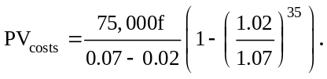
Benefits: The benefits are the payouts after retirement, a 35-year annuity paying $100,000 per year with the first payment 36 years from today. The value of this annuity in year 35 is:
The value today is just the discounted value in 35 years.
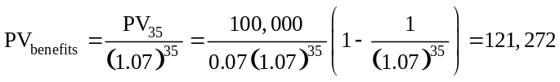
Since the PV of the costs must equal the PV of the benefits (or equivalently the NPV of the cash flows must be zero):
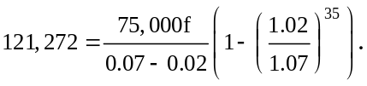
Solving for f, the fraction of your salary that you would like to contribute:
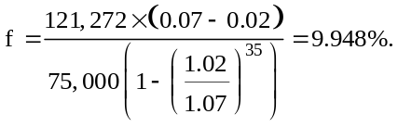
So you would contribute approximately 10% of your salary. This amounts to $7,500 in the first year, which is lower than the plan in the prior problem.
4-46. You have an investment opportunity that requires an initial investment of $5000 today and will pay $6000 in one year. What is the IRR of this opportunity?
Timeline:
0 |  | 1
–5,000 |  | 6,000
IRR is the r that solves:
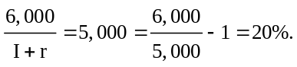
4-47. Suppose you invest $2000 today and receive $10,000 in five years.
a. What is the IRR of this opportunity?
b. Suppose another investment opportunity also requires $2000 upfront, but pays an equal amount at the end of each year for the next five years. If this investment has the same IRR as the first one, what is the amount you will receive each year?
Timeline:
0 |  | 1 |  | 2 |  | 3 |  |  |  |  | 5
-2000 |  |  |  |  |  |  |  |  |  |  | 10,000
IRR solves 2000 = 10000/(1 + r)⁵
So 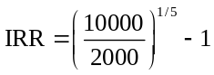=37.97%.
Solution part b:
Timeline:
0 |  | 1 |  | 2 |  | 3 |  |  |  |  | 5
-2000 |  | X |  | X |  | ^{X} |  |  |  |  | ^{X}
X solves:
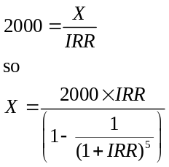
= $949.27
4-48. You are shopping for a car and read the following advertisement in the newspaper: “Own a new Spitfire! No money down. Four annual payments of just $10,000.” You have shopped around and know that you can buy a Spitfire for cash for $32,500. What is the interest rate the dealer is advertising (what is the IRR of the loan in the advertisement)? Assume that you must make the annual payments at the end of each year.
Timeline:
0 |  | 1 |  | 2 |  | 3 |  | 4
–32,500 |  | 10,000 |  | 10,000 |  | 10,000 |  | 10,000
The PV of the car payments is a 4-year annuity:
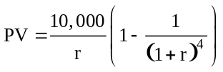
Setting the NPV of the cash flow stream equal to zero and solving for r gives the IRR:
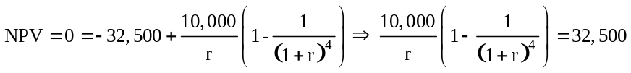
To find r we either need to guess or use the annuity calculator. You can check and see that r = 8.85581% solves this equation. So the IRR is 8.86%.
4-49. A local bank is running the following advertisement in the newspaper: “For just $1000 we will pay you $100 forever!” The fine print in the ad says that for a $1000 deposit, the bank will pay $100 every year in perpetuity, starting one year after the deposit is made. What interest rate is the bank advertising (what is the IRR of this investment)?
Timeline:
0 |  | 1 |  | 2 |  | 3
–1,000 |  | 100 |  | 100 |  | 100
The payments are a perpetuity, so:
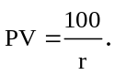
Setting the NPV of the cash flow stream equal to zero and solving for r gives the IRR:
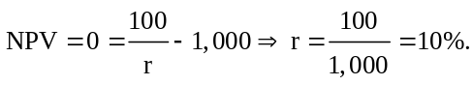
So the IRR is 10%.
4-50. You are considering purchasing a warehouse. The cost to purchase the warehouse is $500,000. Renting the equivalent space costs $20,000 per year. If the annual interest rate is 6%, at what rate must rental cost increase each year to make the cost of renting comparable to purchasing?
We can think of the rental cost as a growing perpetuity. Using the formula for the present value of growing perpetuity, we want to find the growth rate g so that:
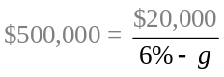 or equivalently 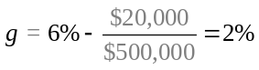
Thus, rental costs must grow at a rate of 2% per year for the cost of renting to be comparable to the cost of purchasing the warehouse.
4-51. The Tillamook County Creamery Association manufactures Tillamook Cheddar Cheese. It markets this cheese in four varieties: aged 2 months, 9 months, 15 months, and 2 years. At the shop in the dairy, it sells 2 pounds of each variety for the following prices: $7.95, $9.49, $10.95, and $11.95, respectively. Consider the cheese maker’s decision whether to continue to age a particular 2-pound block of cheese. At 2 months, he can either sell the cheese immediately or let it age further. If he sells it now, he will receive $7.95 immediately. If he ages the cheese, he must give up the $7.95 today to receive a higher amount in the future. What is the IRR (expressed in percent per month) of the investment of giving up $79.50 today by choosing to store 20 pounds of cheese that is currently 2 months old and instead selling 10 pounds of this cheese when it has aged 9 months, 6 pounds when it has aged 15 months, and the remaining 4 pounds when it has aged 2 years?
Timeline:
2 |  | 3 |  |  | 9 |  | 10 |  |  | 15 |  | 16 |  |  |  | 24
0 |  | 1 |  |  | 7 |  | 8 |  |  | 13 |  | 14 |  |  |  | 22
–79.50 |  |  |  |  | 47.45 |  |  |  |  | 32.85 |  |  |  |  |  | 23.90
The PV of the cash flows generated by storing the cheese is:
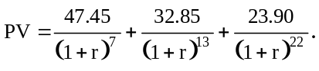
The IRR is the r that sets the NPV equal to zero:
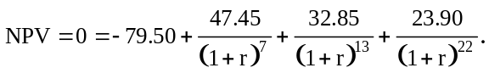
By iteration or by using a spreadsheet (see 4.35.xls), the r that solves this equation is r = 2.28918% so the IRR is 2.29% per month.
4-A.1. Your grandmother bought an annuity from Rock Solid Life Insurance Company for $200,000 when she retired. In exchange for the $200,000, Rock Solid will pay her $25,000 per year until she dies. The interest rate is 5%. How long must she live after the day she retired to come out ahead (that is, to get more in value than what she paid in)?
Timeline:
0 |  | 1 |  | 2 |  | 3 |  |  |  |  | N
–200,000 |  | 25,000 |  | 25,000 |  | 25,000 |  |  |  |  | 25,000
She breaks even when the NPV of the cash flows is zero. The value of N that solves this is:
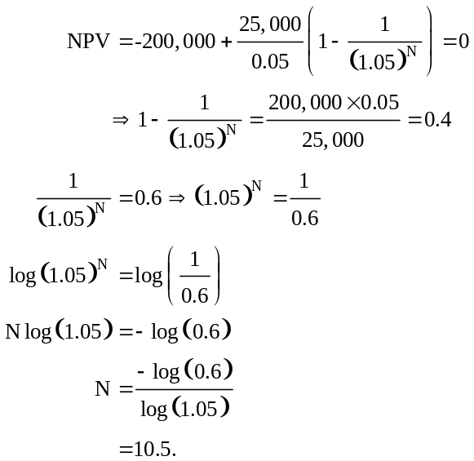
So if she lives 10.5 or more years, she comes out ahead.
4-A.2. You are thinking of making an investment in a new plant. The plant will generate revenues of $1 million per year for as long as you maintain it. You expect that the maintenance cost will start at $50,000 per year and will increase 5% per year thereafter. Assume that all revenue and maintenance costs occur at the end of the year. You intend to run the plant as long as it continues to make a positive cash flow (as long as the cash generated by the plant exceeds the maintenance costs). The plant can be built and become operational immediately. If the plant costs $10 million to build, and the interest rate is 6% per year, should you invest in the plant?
Timeline:
0 |  | 1 |  | 2 |  |  |  |  | N
-10,000,000 |  | 1,000,000 – |  | 1,000,000 - |  |  |  |  | 1,000,000
 |  | 50,000 |  | 50,000(1.05) |  |  |  |  | 50,000(1.05)^{N – 1}
The plant will shut down when:
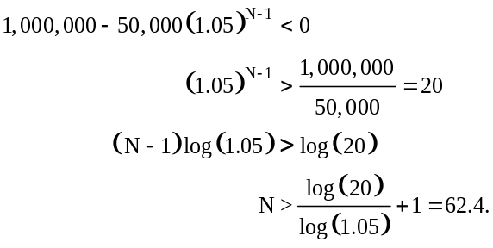
So the last year of production will be in year 62.
The cash flows consist of two pieces, the 62-year annuity of the $1,000,000 and the growing annuity.
The PV of the annuity is:
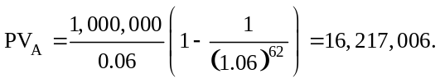

The PV of the growing annuity is:
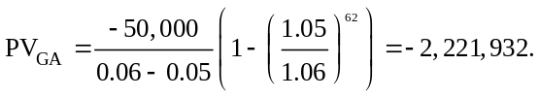

So the PV of all the cash flows is:
So

